Java Promblemsheet - 2

Name: Kaaviya S S Roll. no: 22PT15

1) Write an application that displays the factorial for every integer value from 1 to 10. A factorial
of a number is the product of that number multiplied by each positive integer lower than it.

import java.util.Scanner;
import java.lang.Math;

public class Factorial {
public static void main(String args[]) {

// to find factorial of 10 integers
for(int i=1;i<=10;i++)
{
//to find factorial
long fact = 1;
for(int j=1;j<=i;j++)
{
fact = fact*j;
}
System.out.println("Factorial of " + i + ": " + fact);
}
}
}

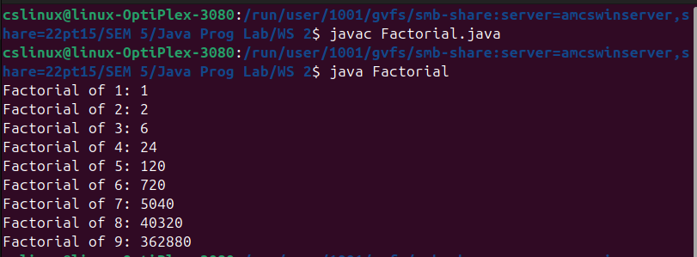

—---------------------------------------------------------------------------------------------------------------------------

2) Write a Java program to solve quadratic equations (use if, else if and else).

import java.util.Scanner;
import java.lang.Math;

public class QuadraticRoots {
public static void main (String args[]) {

Scanner obj = new Scanner(System.in);

float a,b,c;
System.out.println("For a quadratic equation..");
System.out.print("Enter the coefficient of x**2: ");
a = obj.nextFloat();
System.out.print("Enter the coefficient of x: ");
b = obj.nextFloat();
System.out.print("Enter the constant: ");
c = obj.nextFloat();

float D = (b*b) - (4*a*c);

if (D < 0) {
System.out.println("The given quadratic equation has 'Imaginary roots'!");
double x = (-b/2*a);
double y = (Math.sqrt(-D))/(2*a);
System.out.println("Root1: " + x + " + i (" + y + ")");
System.out.println("Root2: " + x + " - i (" + y + ")");
}

else if (D == 0) {
System.out.println("The given quadratic equation has Real and equal roots");
double root = (-b + Math.sqrt(D))/(2*a);
System.out.println("Roots: " + root + " , " + root);
}

else {
System.out.println("The given quadratic equation has Real and unequal roots");
double root1 = (-b + Math.sqrt(D))/(2*a);
double root2 = (-b - Math.sqrt(D))/(2*a);
System.out.println("Roots: " + root1 + " , " + root2);
}

}
}

—---------------------------------------------------------------------------------------------------------------------------

3) Write a program which prints "ONE", "TWO",... , "NINE", "OTHER" if the int variable
"number" is 1, 2,... , 9, or other, respectively. Use "nested-if" statement.

import java.util.Scanner;

public class PrintNumber {
public static void main(String args[]) {

Scanner obj = new Scanner(System.in);

System.out.print("Enter a number [1-9]: ");
int number = obj.nextInt();

if(number < 0)
System.out.println("Number is not in Range!");
else {
if(number==1)
System.out.println("ONE");
else if(number==2)
System.out.println("TWO");
else if(number==3)
System.out.println("THREE");
else if(number==4)
System.out.println("FOUR");
else if(number==5)
System.out.println("FIVE");
else if(number==6)
System.out.println("SIX");
else if(number==7)
System.out.println("SEVEN");
else if(number==8)
System.out.println("EIGHT");
else if(number==9)
System.out.println("NINE");
else
System.out.println("OTHER");
}
}
}

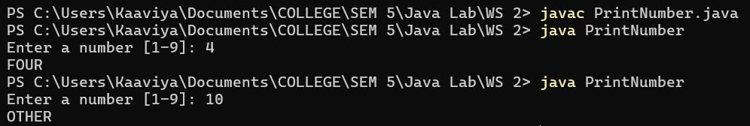

—---------------------------------------------------------------------------------------------------------------------------

4) Write a program called to produce the sum of 1, 2, 3, ..., to 100. Also compute and display the
average.

import java.util.Scanner;

public class Sum_Avg {
public static void main (String args[]) {
Scanner obj = new Scanner(System.in);

System.out.print("Enter n: ");
int n = obj.nextInt();

float sum = (n*(n+1))/2;
float avg = sum/n;
System.out.println("Sum of " + n + " numbers: " + sum);
System.out.println("Average of " + n + " numbers: " + avg);
}
}

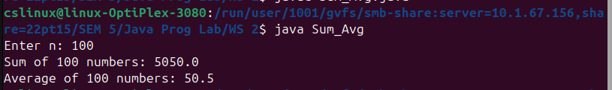

—---------------------------------------------------------------------------------------------------------------------------

5) Write a program to print the first 20 Fibonacci numbers F(n), where F(n)=F(n–1)+F(n–2) and
F(1)=F(2)=1. Also compute their average.

import java.util.Scanner;

public class Fibonacci {

public static int fibonacci(int n) {
if (n==0)
return 0;
else if(n==1)
return 1;
else
return fibonacci(n-2) + fibonacci(n-1);
}

public static void main(String args[]) {

Scanner obj = new Scanner(System.in);

System.out.print("Enter n: ");
int n = obj.nextInt();
float sum = 0;
for(int i=0; i<n; i++)
{
int f = fibonacci(i);
sum = sum + f;
System.out.print( f + " ");
}
System.out.println("");
System.out.println("Average: " + sum/n);

}
}

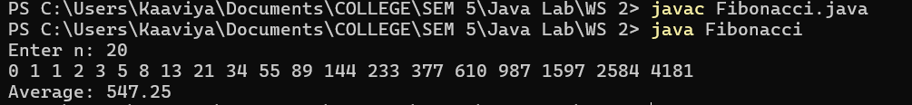

—---------------------------------------------------------------------------------------------------------------------------

6) Write a program to compute whether the given integer number is a palindrome.

import java.util.Scanner;

public class IsPalindrome {

public static int reverse(int n) {
int reversed_num = 0;
while (n > 0) {
reversed_num = reversed_num*10 + (n%10);
n = n/10;
}
return reversed_num;
}

public static void main (String args[]) {

Scanner obj = new Scanner(System.in);

System.out.print("Enter a number: ");
int n = obj.nextInt();

if(reverse(n) == n)
System.out.println("Yes! It is a palindrome.");
else
System.out.println("No! It is not a palindrome.");

}
}

—---------------------------------------------------------------------------------------------------------------------------

7) Write a program in Java to display the cube of the number up to given an integer.

import java.util.Scanner;

public class CubeNumbers {
public static void main(String args[]) {

Scanner obj = new Scanner(System.in);

System.out.print("Enter n: ");
int n = obj.nextInt();

for(int i=1; i<=n; i++)
System.out.println("Cube of " + i + ": " + i*i*i);
}
}

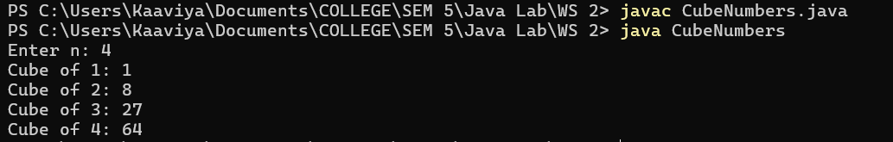

—---------------------------------------------------------------------------------------------------------------------------

8) Write a program that reads integers, finds the largest of them, and counts its occurrences.
Assume that the input ends with number 0. Suppose that you entered 3 5 2 5 5 5 0; the program
finds that the largest is 5 and the occurrence count for 5 is 4.

import java.util.Scanner;

public class Maximum {
public static void main(String args[]) {

Scanner obj = new Scanner(System.in);

System.out.print("Enter no of numbers(elements): ");
int n = obj.nextInt();

int arr[] = new int[n];
System.out.print("Enter the numbers: ");
for(int i=0;i<n;i++) {
arr[i] = obj.nextInt();
}
//to find maximum
int max = 0;
for(int i=0;i<n;i++) {
if(arr[i] > max) {
max = arr[i];
}
}
//to find occurance
int count = 0;
for(int i=0;i<n;i++) {
if(arr[i]==max) {
count ++;
}
}
System.out.println("Maximum element: " + max);
System.out.println("No. of occurence: " + count);
}
}

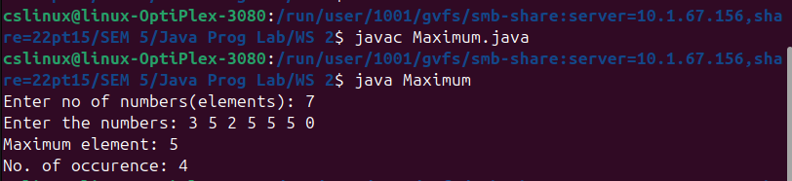

—---------------------------------------------------------------------------------------------------------------------------

9) Write a program in Java to display the pattern like right angle triangle with a number.
1
12
123
1234
12345
123456
1234567
12345678
123456789
12345678910

import java.util.Scanner;

public class PatternPrint {
public static void main(String[] args) {

Scanner obj = new Scanner(System.in);

System.out.print("Enter no. of rows: ");
int n = obj.nextInt();

for(int i=1;i<=n;i++) {
for(int j=1;j<=i;j++) {
System.out.print(j + " ");
}
System.out.println("");
}

}
}

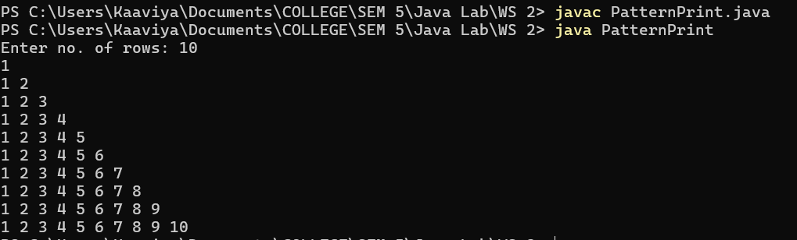

—---------------------------------------------------------------------------------------------------------------------------

10) Write a program that prompts user for the size (a positive integer in int); and prints the
multiplication table as shown: (Use Sentinel-controlled loop)
Enter the size: 10
* | 1 2 3 4 5 6 7 8 9 10
1 | 1 2 3 4 5 6 7 8 9 10
2 | 2 4 6 8 10 12 14 16 18 20
3 | 3 6 9 12 15 18 21 24 27 30
4 | 4 8 12 16 20 24 28 32 36 40
5 | 5 10 15 20 25 30 35 40 45 50
6 | 6 12 18 24 30 36 42 48 54 60
7 | 7 14 21 28 35 42 49 56 63 70
8 | 8 16 24 32 40 48 56 64 72 80
9 | 9 18 27 36 45 54 63 72 81 90
10 | 10 20 30 40 50 60 70 80 90 100

import java.util.Scanner;

public class MultiplicationTable {
public static void main(String args[]) {

Scanner obj = new Scanner(System.in);

System.out.print("Enter n: ");
int n = obj.nextInt();
System.out.println("MULTIPLICATION TABLES");

System.out.print("* | ");
for(int i=1;i<=n;i++) {
System.out.print(i + "\t");
}
System.out.println("");
System.out.println("-------------------------------------------------");
int row=1;
while(row <= n) {
System.out.print(row + " | ");
int col = 1;
while(col <= n) {
System.out.print(row*col + "\t");
col ++;
}
System.out.println("");
row++;
}
}
}

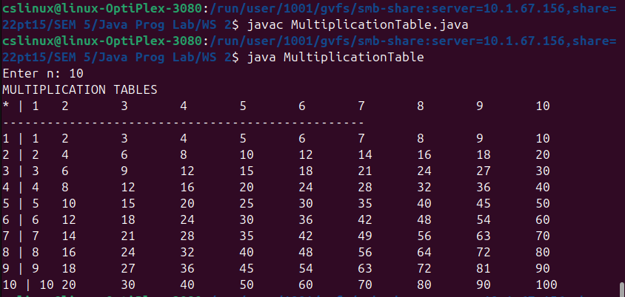

—---------------------------------------------------------------------------------------------------------------------------

11) Write a program for Horizon Phones, a provider of cellular phone service. Prompt a user for
maximum monthly values for talk minutes used, text messages sent, and gigabytes of data
used, and then recommend the best plan for the customer’s needs. A customer who needs fewer than 500 minutes of talk and no text or data should accept Plan A at $49 per month. A customer who needs fewer than 500 minutes of talk and any text messages should accept Plan B at $55 per month. A customer who needs 500 or more minutes of talk and no data should accept either Plan C for up to 100 text messages at $61 per month or Plan D for 100 text messages or more at $70 per month. A customer who needs any data should accept Plan E for up to 3 gigabytes at $79 or Plan F for 3 gigabytes or more at $87.

import java.util.Scanner;

public class HorizonPhones {
public static void main(String args[]) {

Scanner obj = new Scanner(System.in);

System.out.println("Maximum monthly values:");
System.out.print("Enter the no. of minutes for talk time: ");
int talk = obj.nextInt();
System.out.print("Enter no. of text messages sent: ");
int text = obj.nextInt();
System.out.print("Enter no. of gigabytes data used: ");
int data = obj.nextInt();

if(talk<500 && text==0 && data==0)
System.out.println("Suitable plan: Plan A at $49 per month");
else if(talk<500 && text > 0)
System.out.println("Suitable plan: Plan B at $55 per month");
else if(talk>500 && data==0 && text<100)
System.out.println("Suitable plan: Plan C at $61 per month");
else if(talk>500 && data==0 && text >= 100)
System.out.println("Suitable plan: Plan D at $70 per month");
else if(data<3)
System.out.println("Suitable plan: Plan E at $79 per month");
else
System.out.println("Suitable plan: Plan F at $87 per month");
}
}

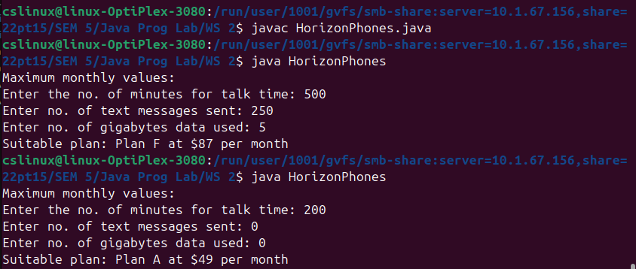

—---------------------------------------------------------------------------------------------------------------------------

12) Acme Parts runs a small factory and employs workers who are paid one of three hourly rates depending on their shift: first shift, $17 per hour; second shift, $18.50 per hour; third shift, $22 per hour. Each factory worker might work any number of hours per week; any hours greater
than 40 are paid at one and one-half times the usual rate. In addition, second- and third-shift
workers can elect to participate in the retirement plan for which 3% of the worker’s gross pay
is deducted from the paychecks. Write a program that prompts the user for hours worked and
shift, and, if the shift is 2 or 3, whether the worker elects the retirement. Display: (1) the hours
worked, (2) the shift, (3) the hourly pay rate, (4) the regular pay, (5) overtime pay, (6) the total
of regular and overtime pay, and (7) the retirement deduction, if any, and (8) the net pay.

import java.util.Scanner;

public class EmployeePay {
public static void main(String args[]) {

Scanner obj = new Scanner(System.in);

System.out.print("Enter no. of hours worked: ");
int hrs = obj.nextInt();
System.out.print("Enter type of shift: ");
int shift = obj.nextInt();
char retirement = 'F';
if(shift==2 || shift==3)
{
System.out.print("Are you electing retirement (y/n)? ");
retirement = obj.next().charAt(0);
}

// to calculate hourly rate
double hr_Rate = 0;
if (shift == 1)
hr_Rate = 17;
else if(shift ==2)
hr_Rate = 18.50;
else
hr_Rate = 22;

//if any overtime
int overtime = 0;
if (hrs > 40)
overtime = hrs - 40;

//regular pay, overtime pay, gross pay, retirement deduction
double regular_pay = (hrs * hr_Rate);
double overtime_pay = (overtime*(1.5*hr_Rate));
double gross_pay = regular_pay + overtime_pay;
double retirement_deduction = 0;
if(retirement=='T')
retirement_deduction = (0.03*gross_pay);
gross_pay = gross_pay - retirement_deduction;

System.out.println("Hours worked: " + hrs);
System.out.println("Shift: " + shift);
System.out.println("Hourly pay Rate: $" + hr_Rate);
System.out.println("Regular pay: $" + regular_pay);
System.out.println("Overtime Pay: $" + overtime_pay);
System.out.println("Total of regular and overtime pay: $" + (regular_pay+overtime_pay));
System.out.println("Retirement Detection: $" + retirement_deduction);
System.out.println("Net pay: $" + gross_pay);
}
}

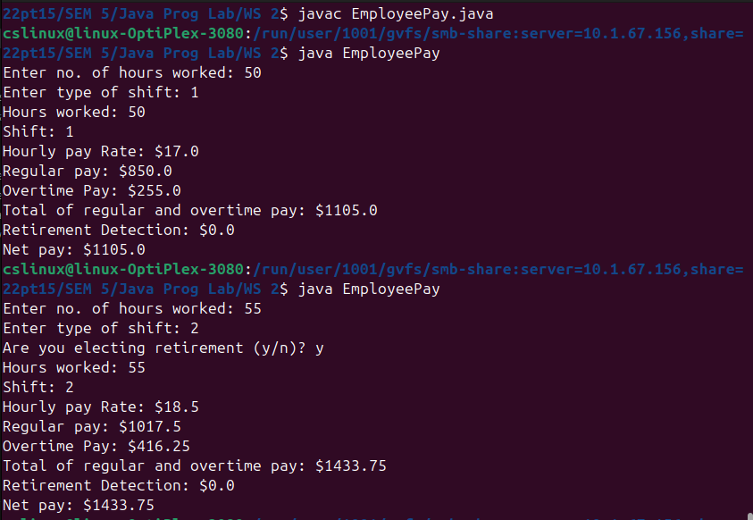

—---------------------------------------------------------------------------------------------------------------------------

13) Write a program called HarmonicSum to compute the sum of a harmonic series, as shown
below, where n=50000. The program shall compute the sum from left-to-right as well as from
the right-to-left. Are the two sums the same? Obtain the absolute difference between these two
sums and explain the difference. Which sum is more accurate?

import java.util.Scanner;

public class HarmonicSum {
public static void main(String args[]) {

Scanner obj = new Scanner(System.in);

System.out.print("Enter n: ");
int n = obj.nextInt();

double sumLR=0;
double sumRL=0;
// Sum from left-to-right
for (int i = 1; i <= n; i++) {
sumLR += (double) 1 / i;
}

// Sum from right-to-left
for (int i = n; i >= 1; i--) {
sumRL += (double) 1 / i;
}

System.out.println("Sum from left-to-right: " + sumLR);
System.out.println("Sum from right-to-left: " + sumRL);
System.out.println("Absolute difference: " + Math.abs(sumLR - sumRL));

}
}

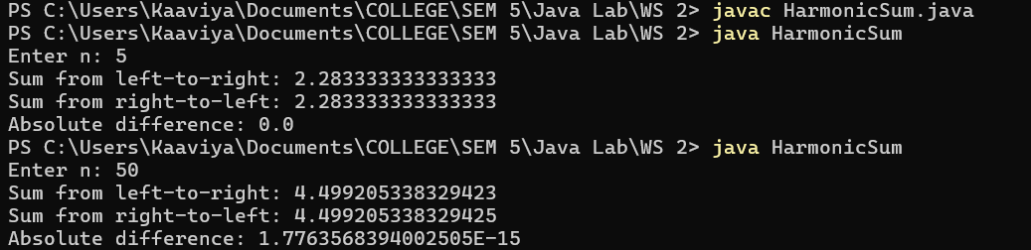
—---------------------------------------------------------------------------------------------------------------------------

14) Both the employer and the employee are mandated to contribute a certain percentage of the
employee's salary towards the employee's pension fund. The rate is tabulated as follows:
Employee's Age Employee Rate(%) Employer Rate(%)
55 and below 20 17
above 55 to 60 13 13
above 60 to 65 7.5 9
above 65 5 7.5
However, the contribution is subjected to a salary ceiling of $6,000. In other words, if an
employee earns $6,800, only $6,000 attracts employee's and employer's contributions, the
remaining $800 does not. Write a program that reads the monthly salary and age of an
employee. Your program shall calculate the employee's, employer's and total contributions (in
double); and print the results rounded to 2 decimal places. For examples,
Enter the monthly salary: $300
Enter the age: 30
The employee's contribution is: $60.00
The employer's contribution is: $51.00
The total contribution is: $111.00

import java.util.Scanner;

public class EmployeePension {
public static void main(String args[]) {

Scanner obj = new Scanner(System.in);

System.out.print("Enter the monthly salary: ");
int salary = obj.nextInt();
System.out.print("Enter the age: ");
int age = obj.nextInt();

if(salary > 6000)
salary = 6000;

double EmployeeRate = 0;
double EmployerRate = 0;
if(age <= 55) {
EmployeeRate = 20;
EmployerRate = 17;
}
else if(age>55 && age <=60) {
EmployeeRate = 13;
EmployerRate = 13;
}
else if(age>60 && age <=65) {
EmployeeRate = 7.5;
EmployerRate = 9;
}
else {
EmployeeRate = 5;
EmployerRate = 7.5;
}

double Employee_c = salary*(EmployeeRate/100);
double Employer_c = salary*(EmployerRate/100);
System.out.println("The employee's contribution is: " + String.format("%.2f",Employee_c));
System.out.println("The employer's contribution is: " + String.format("%.2f",Employer_c));
System.out.println("The total contribution is: " + String.format("%.2f",(Employee_c+Employer_c)));
obj.close();
}
}

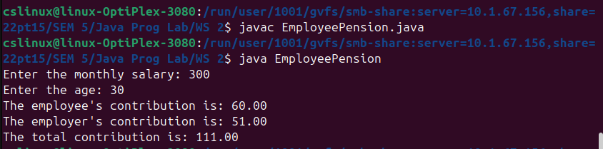

—---------------------------------------------------------------------------------------------------------------------------

15) An ISBN-10 (International Standard Book Number)
consists of 10 digits: d1d2d3d4d5d6d7d8d9d10. The last digit, d10, is a checksum,
which is calculated from the other nine digits using the following formula:
(d1 * 1 + d2 * 2 + d3 * 3 + d4 * 4 + d5 * 5 +
d6 * 6 + d7 * 7 + d8 * 8 + d9 * 9) % 11
If the checksum is 10, the last digit is denoted as X according to the ISBN-10
convention. Write a program that prompts the user to enter the first 9 digits and
displays the 10-digit ISBN (including leading zeros). Your program should read
the input as an integer.

import java.util.Scanner;

public class ISBN {
public static void main(String args[]) {

Scanner obj = new Scanner(System.in);

System.out.print("Enter the first 9 digits of an ISBN number as integer: ");
int num = obj.nextInt();

System.out.print("The ISBN-10 number is ");
int temp = num;
int div = 100000000;
int sum = 0;
for(int i=1;i<=9;i++) {
int d = temp/div;
System.out.print(d);
sum = sum + d*i;
temp = temp%div;
div = div/10;
}
int checksum = sum%11;

if (checksum == 10)
System.out.println("X");
else
System.out.println(checksum);

obj.close();
}
}

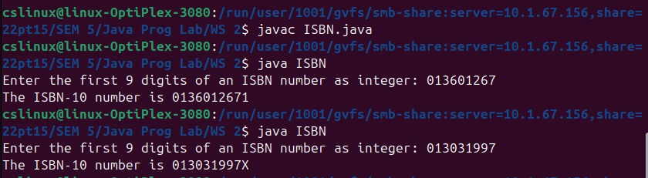

—---------------------------------------------------------------------------------------------------------------------------

16) Write a program called CozaLozaWoza which prints the numbers 1 to 110, 11 numbers per
line. The program shall print "Coza" in place of the numbers which are multiples of 3, "Loza"
for multiples of 5, "Woza" for multiples of 7, "CozaLoza" for multiples of 3 and 5, and so on.
The output shall look like:
1 2 Coza 4 Loza Coza Woza 8 Coza Loza 11
Coza 13 Woza CozaLoza 16 17 Coza 19 Loza CozaWoza 22
23 Coza Loza 26 Coza Woza 29 CozaLoza 31 32 Coza

import java.util.Scanner;

public class CozaLozaWoza {
public static void main(String args[]) {

Scanner obj = new Scanner(System.in);

System.out.print("Enter n: ");
int n = obj.nextInt();

for(int i=1;i<=n;i++) {
if(i%3!=0 && i%5!=0 && i%7!=0)
System.out.print(i);
else {
if(i%3==0)
System.out.print("Coza");
if(i%5==0)
System.out.print("Loza");
if(i%7==0)
System.out.print("Woza");
}
System.out.print("\t");
if(i%11==0)
System.out.println("");
}
}
}

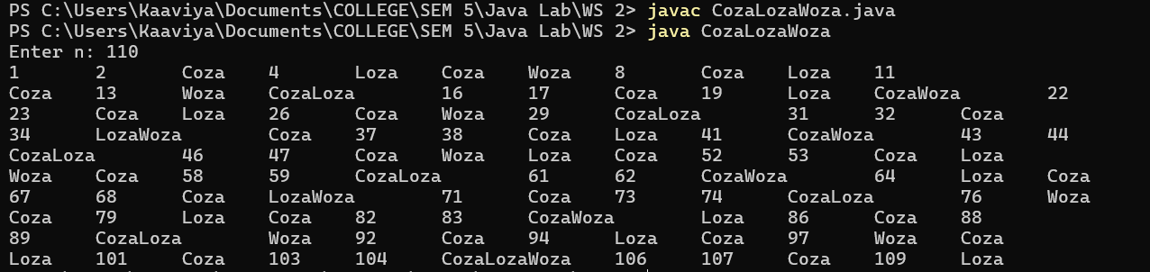

—---------------------------------------------------------------------------------------------------------------------------

17) The progressive income tax rate is mandated as follows:
Taxable Income Rate (%)
First $20,000 0
Next $20,000 10
Next $20,000 20
The remaining 30
For example, suppose that the taxable income is $85000, the income tax payable is $20000*0%
+ $20000*10% + $20000*20% + $25000*30%.
Write a program that reads the taxable income. The program shall calculate the income tax
payable (in double); and print the result rounded to 2 decimal places.

import java.util.Scanner;

public class IncomeTax {
public static void main(String args[]) {

Scanner obj = new Scanner(System.in);

System.out.print("Enter the taxable income: $");
int income = obj.nextInt();

double tax = 0;
if(income <= 20000)
tax = 0.0;
else if(income>20000 && income<=40000)
tax = (income-20000)*0.1;
else if(income>40000 && income<=60000)
tax = (20000*0.1) + (income-40000)*0.2;
else
tax = (20000*0.1) + (20000*0.2) + (income-60000)*0.3;

System.out.printf("The income tax payable is: $%.2f \n",tax);
obj.close();
}
}

—---------------------------------------------------------------------------------------------------------------------------

18) Write a program that reads a list of positive numbers and displays the largest number in the list followed by the number of times it appears using function. The list should be terminated by 0. There is no 0 in the list and there is at least one number before the 0. Do not use an array or
non-main method to answer this question. Write your code so that given the same input it
would produce the same output like the following example execution:
Please type in your numbers -->1 2 3 2 4 5 6 6 0
The largest number is 6 and it appears 2 times

import java.util.Scanner;

public class Maximum_count {

public static void main(String[] args) {

Scanner obj = new Scanner(System.in);

System.out.println("Enter the list of numbers and terminate by 0: ");
System.out.print("Please type in your numbers --> ");

int max = 0;
int count = 0;
int num=1;
while(num!=0) {
num = obj.nextInt();
if(num > max) {
max = num;
count = 1;
}
else if(num==max)
count += 1;
}

System.out.println("The largest number is " + max + " and it appears " + count + " times");
obj.close();
}
}

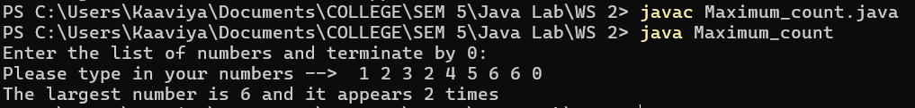

—---------------------------------------------------------------------------------------------------------------------------

19) Print the average blood pressure for different people. Each input has a patient ID, the number of readings for that patient, followed by the actual blood pressure readings. (Use Sentinel- controlled loop)
Sample input:
ID# #Readings Actual readings
4567 5 180 140 153 170 130
2318 2 170 215
5232 3 150 151 145
Sample Output:
For patient ID#: 4567 average BP = 154.60
For patient ID#: 2318 average BP = 192.50
For patient ID#: 5232 average BP = 148.66

import java.util.Scanner;

public class BloodPressure {
public static void main(String args[]) {

Scanner obj = new Scanner(System.in);

System.out.println("ID# #Readings Actual readings");
int id = obj.nextInt();
while(id!=0) {

int num_read = obj.nextInt();
float bp[] = new float[num_read];
for(int i=0; i<num_read; i++) {
bp[i] = obj.nextFloat();
}

double avg_bp = 0;
for(int i=0; i<num_read; i++) {
avg_bp += bp[i];
}
avg_bp = avg_bp/num_read;
System.out.printf("For patient ID#: %d average BP = %.2f \n\n", id, avg_bp);

System.out.println("ID# #Readings Actual readings");
id = obj.nextInt();
}

obj.close();
}
}

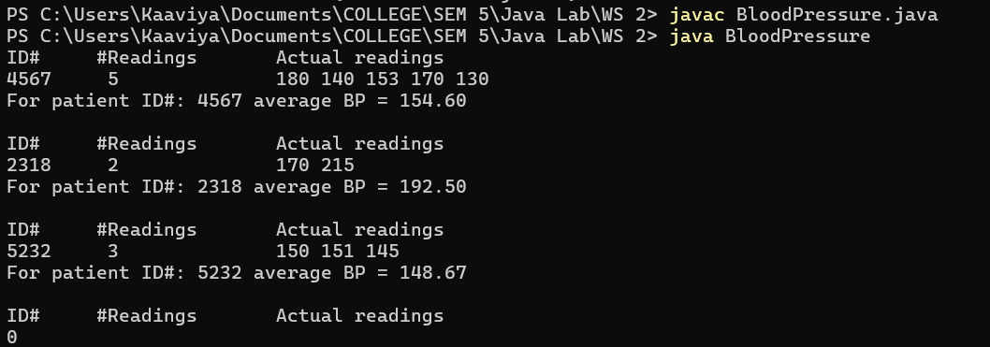

—---------------------------------------------------------------------------------------------------------------------------

20) Write an application that allows a user to enter any number that converts it to a roman numeral until the user enters 99.
Roman numerals are represented by seven different symbols: I, V, X, L, C, D and M.
Symbol Value
I 1
V 5
X 10
L 50
C 100
D 500
M 1000
For example, 2 is written as II in Roman numeral, just two one's added together. 12 is written
as XII, which is simply X + II. The number 27 is written as XXVII, which is XX + V + II.

import java.util.Scanner;

public class RomanNumeral {
public static void main(String args[]) {

Scanner obj = new Scanner(System.in);

int[] values = {1000, 900, 500, 400, 100, 90, 50, 40, 10, 9, 5, 4, 1};
String[] symbols = {"M", "CM", "D", "CD", "C", "XC", "L", "XL", "X", "IX", "V", "IV", "I"};

int num = 0;
while(true) {

System.out.print("Enter a number (99 to exit): ");
num = obj.nextInt();

if(num<0 || num>=100)
System.out.print("Enter a number in valid range (1-99)!");

else if(num==99)
break;

else {
StringBuilder roman = new StringBuilder();
for(int i=0; i<values.length; i++) {
while (num >= values[i]) {
num = num - values[i];
roman.append(symbols[i]);
}
}
System.out.println("Roman Numeral is: " + roman.toString());
}
}
obj.close();
}
}





